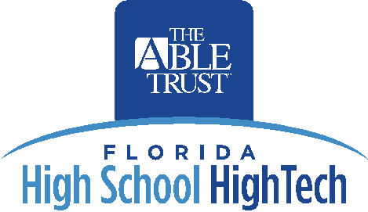

Return Address

Date

Recipient Address

Dear _________,

I would like to introduce you to the Florida High School High Tech Program. High School High Tech (HSHT) is a nationally recognized program that exposes youth with disabilities to a wide variety of careers with an emphasis on technology-related and in-demand careers. HSHT provides students the opportunity to develop their academic and leadership skills as well as build self-confidence and other job-related skills.

ORGANIZATION administers the program in COUNTY and in partnership with The Able Trust. The Able Trust is a public/private foundation that operates as a key leader in providing Floridians with disabilities opportunities for successful employment. HSHT is a premier program of The Able Trust and operates in 40 counties throughout the state.

HSHT provides career-development workshops; site visits to business, college, and post-secondary institutions; job shadowing; summer internships; and much more. The goals of the program are to:

- Improve participation in education and vocational-related activities leading to increased employment opportunities for youth with disabilities;
- Increase enrollment in postsecondary education; and
- Reduce the high school dropout rate.

Currently HSHT operates at SCHOOL NAME(S). We aspire to have strong relationships with state and community organizations to ensure the HSHT students are aware of available resources and information to assist in their academic and employment endeavors.

We look forward to working with you to provide to provide quality services and supports for students with disabilities in COUNTY.

Sincerely,

(Program Coordinator Name)
CONTACT INFORMATION

